
Desert Tortoise Preserve Committee, Inc.
PO Box 940, Ridgecrest, CA 93556
Phone:(442)-294-4258
E-mail: • dtpc@tortoise-tracks.org

For Immediate Release
March 6, 2023

Ron Berger, President
Desert Tortoise Preserve Committee, Inc.
503-522-6611
ron.berger@tortoise-tracks.org

Desert Tortoise Research Natural Area (DTRNA) to Celebrate its 50th (Golden) Anniversary on Saturday, March 25th, 2023 at 9am.
Ridgecrest, CA: The Desert Tortoise Preserve Committee (DTPC) today announced that it will be holding an event in conjunction with the Bureau of Land Management at the Desert Tortoise Research Natural Area (DTRNA) commemorating fifty years of protection for the California state reptile, Agassiz’s Desert Tortoise.

All are welcome. The program starts at 9am on Saturday, March 25th, 2023 at the DTRNA, located near California City, CA (see directions below). There will be naturalist guided trail walks, followed by presentations by DTPC founder Dr. Kristin Berry, and others. (Details on speakers and presenters to follow)

The day’s agenda is:

9am – Tortoise Area Trail Walks *
10am – Speakers / Presentations
11am (approx.) – Naturalist Led Trail Walks *
Noon – Program Ends

* And meet Tortoises

Please see details and directions below:

- Protection of the DTRNA is a truly remarkable achievement in which quite literally thousands of concerned citizens working together with government agencies over five decades have created a most important space (39.5 square miles!) in which the California State Reptile, Agassiz’s Desert Tortoise, Mohave ground squirrels and other native species may reside, hopefully in perpetuity.

- In 1971 and 1972 DTPC founder, Dr. Kristin Berry, began working with the Bureau of Land Management (BLM) to outline a protected area for the western Mojave ecosystem, with the desert tortoise as the key or focal species.

- In 1973, the BLM published the boundaries of what became the DTRNA, as part of its management plan entitled, “Management of Recreational Vehicle Use” published by the U.S. Department of the Interior. This act was followed by fencing of the perimeter and posting signs to help direct OHV riders and others including sheep grazers to keep out of the area in order to protect the tortoise as well as the plants it needs to survive. The following year saw the establishment of the DTPC by Dr. Berry, Laura Stockton, and others.

- DTPC is a nonprofit charitable organization established in 1974 to promote the welfare of the desert tortoise in the wild through land acquisition and management, scientific research, and educational outreach. The DTPC currently owns or manages over 32,000 acres of habitat for the desert tortoise and other sensitive species in the Mojave and Colorado deserts. In collaboration with the U.S. Bureau of Land Management (BLM) and other state and federal agencies, we were instrumental in establishing the Desert Tortoise Research Natural Area (Natural Area) 50 years ago. During these years, the DTPC, in partnership with BLM, has painstakingly fenced the area, installing signs to ask the public not to enter the area, protecting the tortoises within from the deleterious and often fatal impacts of off road vehicles, livestock grazing, and other uses. In addition, BLM and the DTPC have conducted surveys, contributed to important research, provided volunteers to perform field work, and provided funding in support of such activities. Today, the DTPC helps manage the Natural Area under a cooperative agreement with the BLM. The BLM importantly provides the naturalist trailers, law enforcement to monitor the fence line, and a great deal more. Since the creation of the Natural Area, Congressionally-appropriated Land and Water Conservation Funds, private donations, and mitigation funds received through contractual agreements with developers and state and federal agencies have been utilized to acquire private lands within and adjacent to the Natural Area. Title to substantial acreage the DTPC acquired within the Natural Area has been transferred to the BLM with the understanding that it will continue to be protected under existing federal mandates. In addition to transferring lands in fee title to the BLM, the DTPC has also conveyed, and is in the process of conveying, conservation easement deeds to the State of California.

- The DTPC utilizes contributed funds to, among other things, acquire additional tortoise habitat, retain title to it in perpetuity, and fence and protect it. Some of these additional lands are located between the mountain ranges to the north and the Natural Area, addressing the need for habitats at higher elevations due to climate change. The DTPC intends to enhance protection of the Natural Area with more secure, professionally signed and patrolled fencing and walls, where appropriate, ensuring that this pristine habitat remain undisturbed in perpetuity.

- In addition to its importance as protected habitat for wildlife, the Natural Area serves as an important area for research, educational outreach, and contemplative recreation. Universities, colleges, and government research agencies have undertaken major projects researching tortoises, the rare and endemic Mohave ground squirrels and other mammals, birds, lizards, and vegetation in this protected, fenced area. The DTPC has been able to support a number of the research efforts. These projects have resulted in many publications that help guide conservation and management in the desert, with additional projects currently underway. Equally important, students have an opportunity to conduct studies and learn in a protected area where they and their work can thrive. Numerous ‘first’ discoveries have taken place at the Natural Area. Such research would simply not be possible were the area not protected.

- A scientific survey published in 2014 shows that there is six times the density of tortoises found within the Natural Area as on adjacent critical habitat. In addition, if we look solely at the densities of adult breeding tortoises, we find that there are 3 to 5 times as many at the Natural Area as can be found in federally-designated critical habitats.

- In 1989, the DTPC and the BLM developed a Naturalist Program. With funding support from BLM, the DTPC has staffed Naturalists at the Natural Area for 3 months every spring since then. The Natural Area typically receives over a thousand visitors during this 3 month period, with Naturalists conducting programs for school and community groups, while interacting with almost all visitors passing through.

- In addition to expanding, monitoring and protecting the Natural Area and other parcels, the DTPC takes a very active role in addressing the threats described above. Specific examples of the work we do include:

a. Conducting raven nest surveys, and supplying our findings to the U.S. Fish and Wildlife Service, which oils the eggs, preventing the eggs from hatching, reducing raven predation.
b. Creating the Coalition for a Balanced Environment (CBE), and growing it to nineteen members including The Nature Conservancy, The Tortoise Conservancy, The Desert Tortoise Council, Transition Habitat Conservancy, Defenders of Wildlife and the Mohave Desert Land Trust. The CBE works to build community and political awareness of the raven issue and effect meaningful regulation and compliance with these to reduce subsidization.
c. Building awareness by the off road rider community through signage, brochures, public appearances, and participation in meetings of Friends of Jawbone.
d. With the support of BLM, removing invasives on an ongoing basis, treating areas as needed to effect restoration as well as trail camouflage in areas of high incursions.
e. Monitoring all activities which might unwittingly increase raven population or subsidies and actively participating in the vetting process to insure that every development be constructed in such a way as to provide no perching or nesting opportunities.

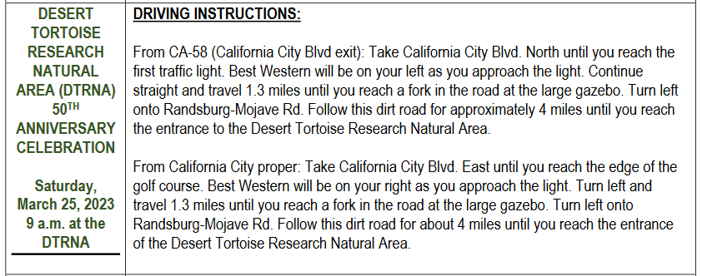
Please follow the directions below carefully.
If you would like to geotag your photos, please see below:

35.191803, -117.881104

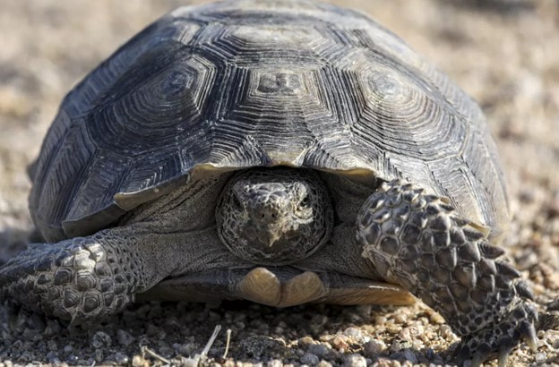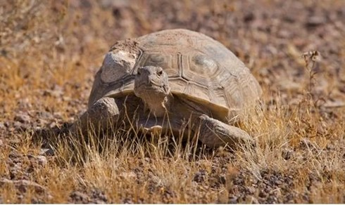

Photo and interview opportunity:
Saturday, March 25, 2023 – 9am to Noon
Desert Tortoise Research Natural Area
California City, CA

Contacts to media:
Ron Berger, President
503-522-6611
ron.berger@tortoise-tracks.org

